**Bug report of Buggy Cars Rating (Chrome browser)**

|  |  |
| --- | --- |
| Bug ID | BG01 |
| Bug Title | UI is not refreshing after login to the portal |
| Steps to reproduce | 1. Launch <https://buggy.justtestit.org> 2. Enter the login name and password then click on Login |
| Expected result | After successfully login into the portal, the page should be refreshed and the user should be directed to the home page. |
| Actual result | After successfully login into the portal, the home page does not refresh. |
| Assigned to | Developer |
| Build | 1.0.0 |
| Reported By | Saburi K |
| Reported on | 06 May 2021 |
| Severity | Critical |
| Status | New |
| Resolution | Unresolved |
| Fix version/s | None |

Bug screenshot:

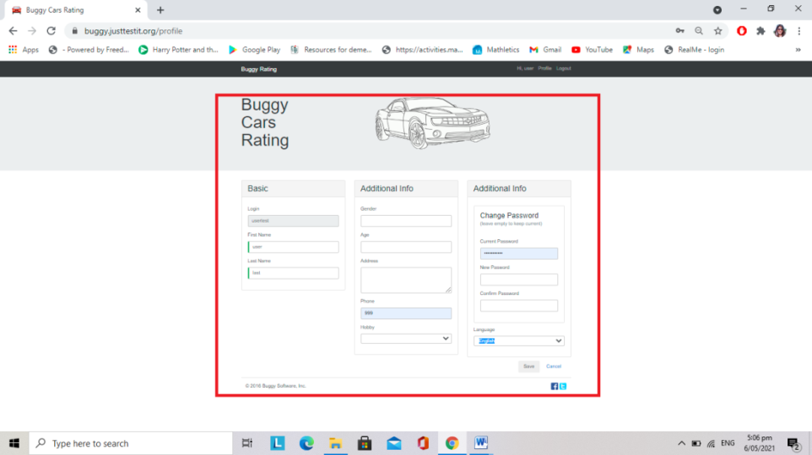

|  |  |
| --- | --- |
| Bug ID | BG02 |
| Bug Title | New registration accepts special characters for the first name and last name field: !@#$ and %^&* |
| Steps to reproduce | 1. Launch the url <https://buggy.justtestit.org> 2. Register as a new user 3. Enter the Login name, Password and Confirm Password field along with the below details:   First Name:!@#$  Last Name: %^&*   1. Click on the Register |
| Expected result | An error message “Special characters are not allowed in First name and Last name field” and should restrict user to successfully register on the portal |
| Actual result | No error message and registration is successful |
| Assigned to | Developer |
| Build | 1.0.0 |
| Reported By | Saburi K |
| Reported on | 06 May 2021 |
| Severity | Critical |
| Status | New |
| Resolution | Unresolved |
| Fix version/s | None |

Bug screenshot:

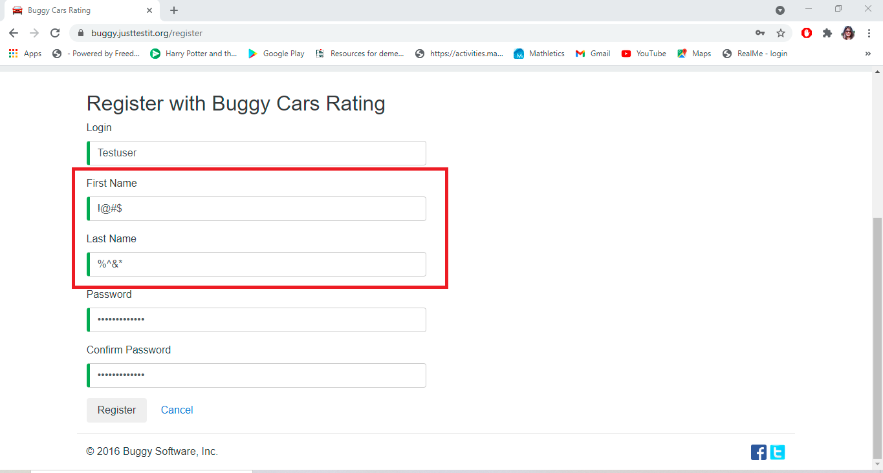

|  |  |
| --- | --- |
| Bug ID | BG03 |
| Bug Title | Portal is not compatible with Mozilla Firefox browser (cross browser testing) |
| Steps to reproduce | 1. Launch the url <https://buggy.justtestit.org> 2. Login with valid User Name and Password 3. Navigate to the “Popular make” module |
| Expected result | Land to the “Popular make” page from the home page |
| Actual result | The page isn't loading properly |
| Assigned to | Developer |
| Build | 1.0.0 |
| Reported By | Saburi K |
| Reported on | 06 May 2021 |
| Severity | Critical |
| Status | New |
| Resolution | Unresolved |

Bug screenshot:

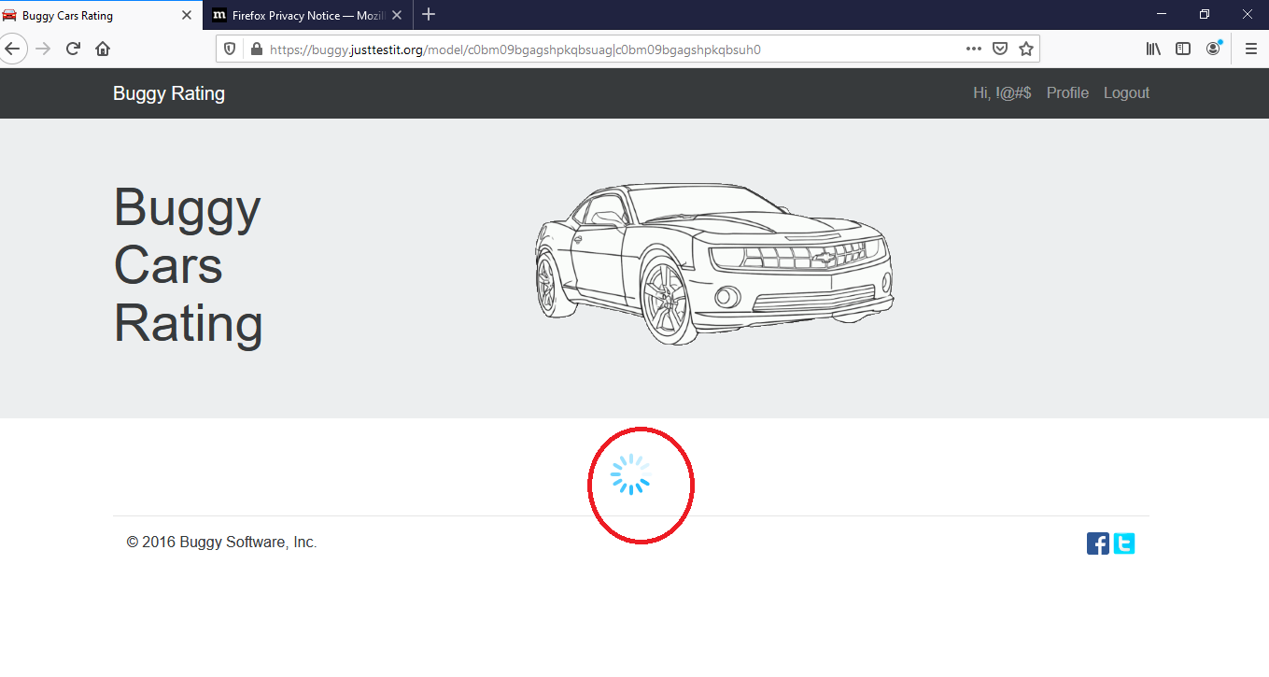

In addition, while performing exploratory testing on the given portal, I discovered some other issues of medium to low severity. Some of them are as follow:

1. In the “Popular make” module, the user cannot see the author’s name for the Diablo car
2. On the home page forget username & password option is missing
3. On the registration page there is no provision to get the details for the password/username recovery
4. In the “Profile” module at “additional info” section for “Phone number” field there is no limitation for digits
5. In the “Profile” module at the “additional info” section, “Gender” field drop-down option does not show all the options once any option is selected
6. Error messages on “Profile” module and other pages are not user friendly. It gives technical details which does not make sense to users